***Name: Tasneem Khalied Abdelrazek Mohamed Amer***

***B.N.: 11*** , ***SECTION:*** ***12*** , ***GROUP:***2

***Date:*** ***6/6/2021***

***Topic***: Artificial Intelligence

***Application Brief:***

Artificial intelligence (AI) is the ability of a digital computer or computer-controlled robot to perform tasks commonly associated with intelligent beings. there a some applications of A.I. like computers that play chess and self car driving .the A.I. is very important these days ,it makes our life much easier and faster ,it save our efforts for more important things . There are 4 types of A.I. that help us now days. But that doesn’t mean that A.I. don’t have any cons, as our life everything have pros and cons. Finally A.I. has some techniques that have their usages in different fields of life.

***Screenshots:***

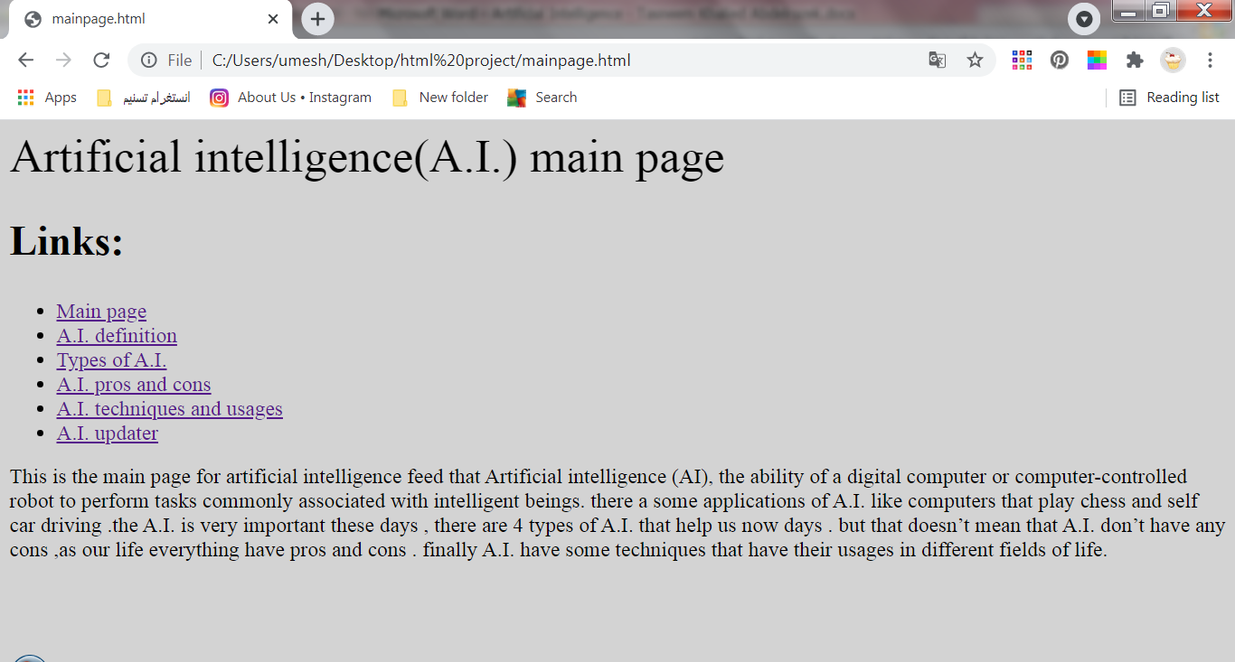

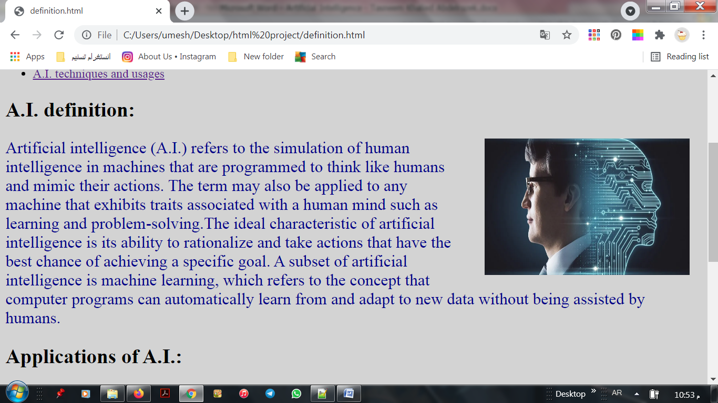

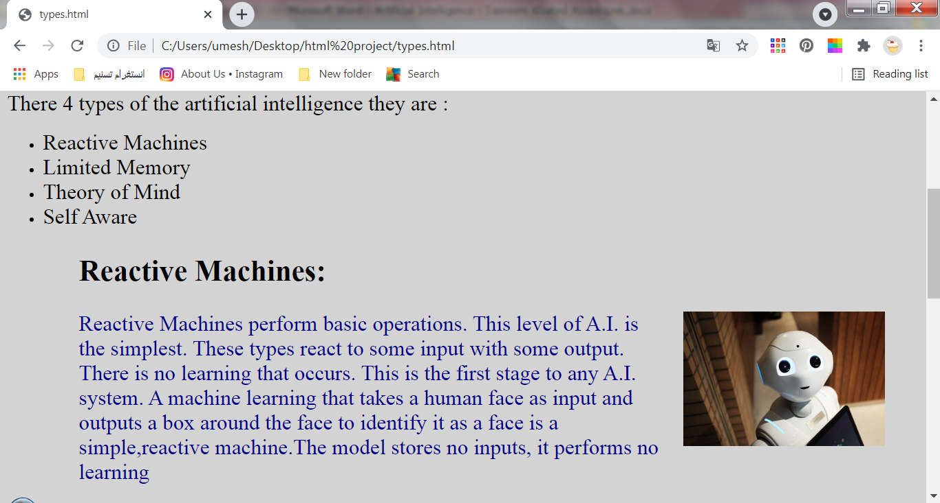

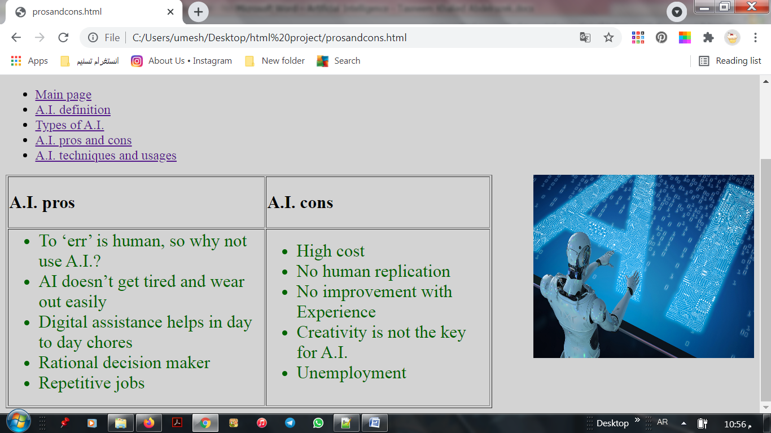

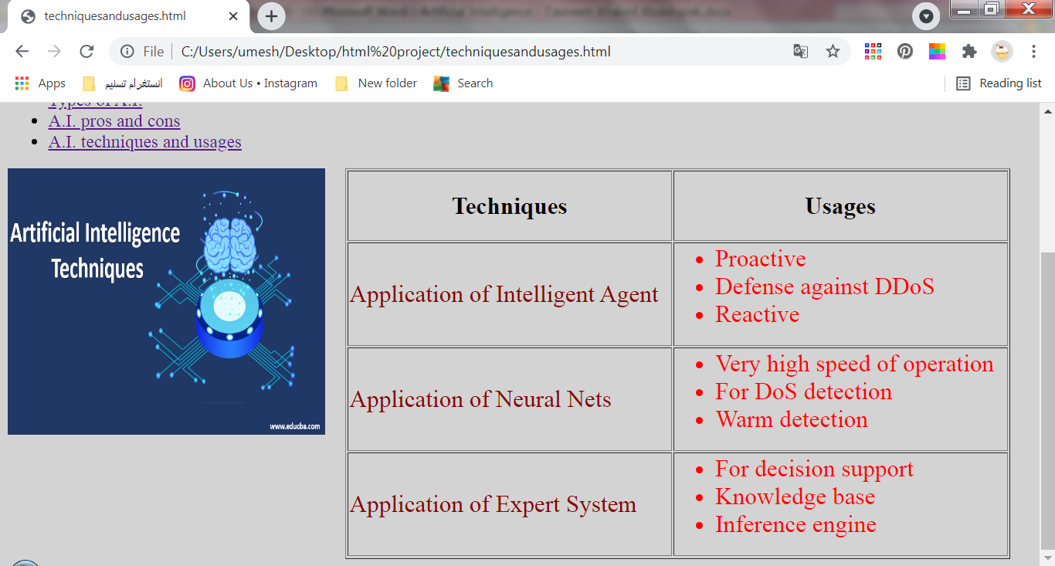

***Source code:***

